**ATIENO SHARON**

**SCCJ/00659/2021**

**ASSIGNMENT 2**

**SCRIBLES (TO-DO LIST APP)**

**METHODOLOGY USED**

Agile methodology is the best methodology to use for a To-do list app.

This methodology allows for continuous improvement at every stage.

It favors the continuous cycle of planning, executing and evaluating.

**1.CONTEXT DIAGRAM**

CONTEXT MODEL

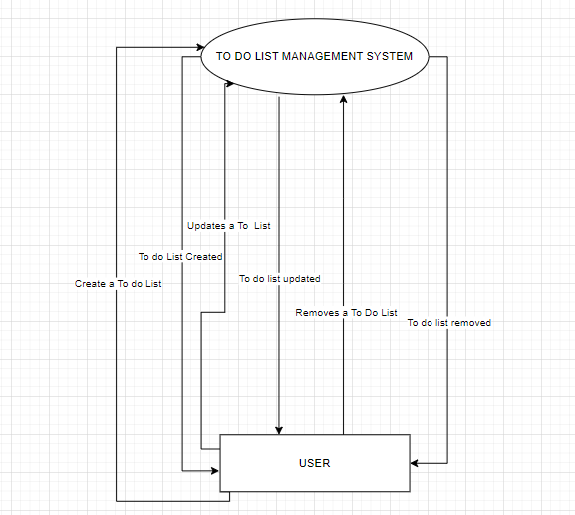

**2. INTERACTION DIAGRAM**

USE CASE DIAGRAM

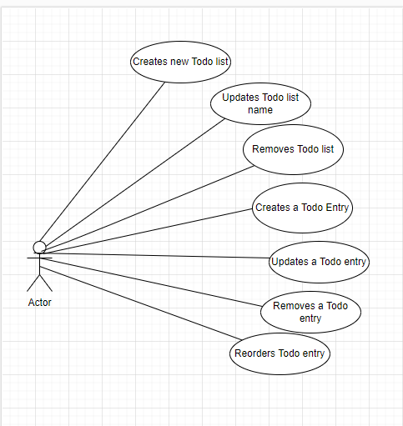

**3. STRUCTURAL MODEL**

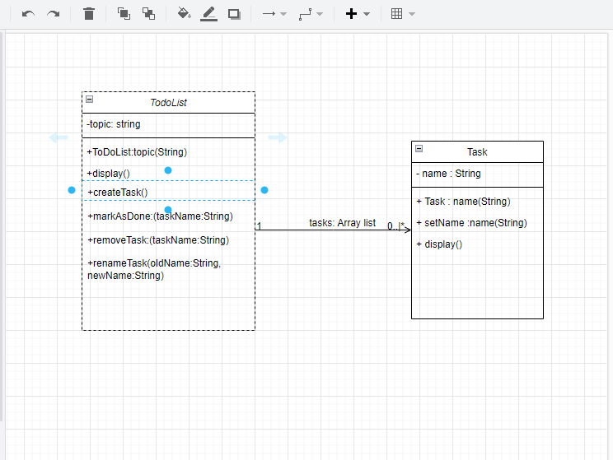

**4. BEHAVIOURAL MODEL**

ACTIVITY DIAGRAM